FALL 2019
Course Start Date: Sept. 4, 2019
Last Lecture: Nov. 27, 2019
Final Exam: cc. Dec 5 - 20, 2019
Reading Week: Includes October 16, 2019
Drop: Nov. 8, 2019

‘Elements of Law: Part One’

(AP/ADMS 2610)

(Note: Subject to Further Revision)
COURSE OUTLINE

Faculty of Liberal Arts and Professional Studies
School of Administrative Studies
York University

COURSE INSTRUCTOR / DIRECTOR:

Richard O. Gasparini,
BA (Carleton), JD (Ottawa), LLM (Osgoode), MBA (Bradford), PhD(c) (Manchester Metropolitan), CM (James Madison), CIM, CMGR, FCMI-CMGR, FRSA, FInstLM, AFSALS (London), Cert. Ad. Ed (Seneca). (ret.) OPFC

Office Hours: 6:30 pm – 7:00 pm in the classroom prior to the lecture
Classroom: See course website for classroom assignment
Email: rgaspar@yorku.ca
Research Website: https://richardgasparini.academia.edu.

FALL 2019 - IMPORTANT DATES

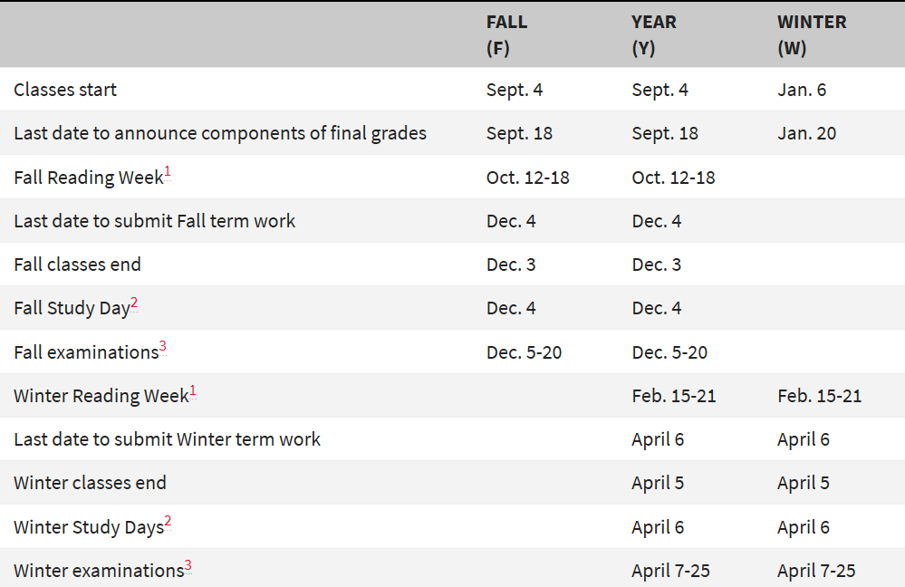

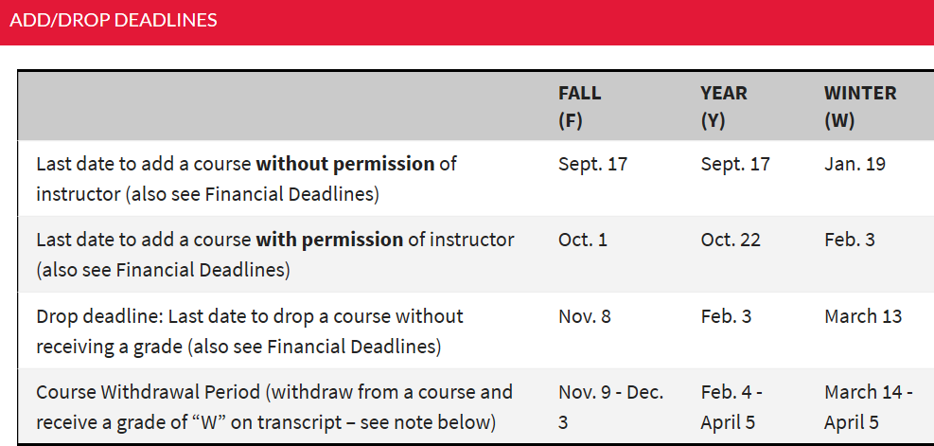

INSTRUCTOR BIOGRAPHY

Professor Richard Gasparini is an Ontario Barrister, Solicitor and Notary Public and instructor of Business Law at the School of Liberal Arts and Professional Studies, York University, Toronto. He was called to the Bar of Ontario in 1979 in which province he practiced in private law firms until 1998 when he became regional Counsel for the Canada Post Corporation. In 2010 he began teaching in the paralegal program at Seneca College (Newnham Campus) in Toronto which led to his current position as Academic Program Manager of the paralegal certificate program in the Faculty of Continuing Education. During his lengthy legal career, he practiced in many areas of law, providing advice to a wide variety of private and corporate clients in Ontario and the rest of Canada. In 2015 he was appointed to the Ontario Professional Foresters’ Council by the Lieutenant Governor of the Province of Ontario where he sat on the investigations sub-committee until 2017. Professor Gasparini is a former elected member of the York University Academic Standards and Pedagogy Committee and the sub-committee on Quality Assurance for the University.

He holds a Bachelor of Arts degree (with distinction) from Carleton University, a Juris Doctorate from the University of Ottawa, a Master of Laws degree from Osgoode Hall Law School and a Master of Business Administration degree (with distinction) from the University of Bradford School of Management and Law, U.K. He is a Chartered Manager certified in management and administration by the Canadian Institute of Management (CIM) as well as the Institute of Certified Professional Managers (CM) in the U.S.A. He is both a Chartered Manager (CMGR) and Fellow of the Chartered Management Institute, U.K. (FCMI). He is also a Fellow of the Royal Society of Arts (FRSA), a Fellow of the Institute of Leadership Management, U.K. and an Associate Fellow of the Society for Advanced Legal Studies (at the University of London, U.K.). He has authored several published academic monographs and appears as Counsel in numerous reported tribunal decisions. He is an active member of the Academy of Management (USA), the Academy of International Business (at Michigan State University), the British Academy of Management, the Canadian Anthropology Society, the American Society of International Law, the Society of Legal Scholars (U.K.), the North Central Sociological Association, the Canadian Law and Society Association (where he is an emeritus member), the World Association for Public Opinion and Research (at the University of Nebraska-Lincoln) and the International Sociological Association.

He is the co-author of “Public and Private Business Law in Canada” © 2018, awaiting publication by Captus Press Inc., Toronto ON.

Required Texts: The required text for the course is Contemporary Canadian Business Law, Principles and Cases, (2015) 11th Edition, J.A. Willes & J.H. Willes, McGraw-Hill Ryerson (“Textbook”) which is available in the York University Bookstore.

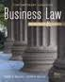

Extra Reading:

While not required for this course, interested students who wish to pursue the topic “Sources of Law” (Chapters 1 and 2) in greater detail might wish to read excerpts from the following texts: Thomas M.J. Bateman, Janet L. Hiebert, Rainer Knopff and Peter H. Russell, The Court and the Charter: Leading Cases, (2008) Emond Montgomery Publications Limited, Toronto, Canada and Thomas M.J. Bateman, Janet L. Hiebert, Rainer Knopff and Peter H. Russell, The Court and the Constitution: Leading Cases, (2008) Emond Montgomery Publications Limited, Toronto, Canada

While not require for this course, interested students who wish to pursue the topic “International Business Law” (Chapter 33) in greater might wish to read excerpts from the following text: Mary Jo Nicholson and Alyssa Brierley, Legal Aspects of International Business: A Canadian Perspective (2015) (3ed), Emond Montgomery Publications Ltd. Toronto, Canada.

The following texts are excellent supplementary reference guides:

CONTRACTS: Fridman, The Law of Contract in Canada (6th ed., 2011)
CORPORATIONS: McGuinness, Canadian Business Corporations Law (2nd ed., 2007)
EMPLOYMENT LAW: England & Christie, Employment Law in Canada (3rd ed., looseleaf)

ENVIRONMENTAL LAW: Benedickson, Environmental Law (3rd ed., 2009)
INTELLECTUAL PROPERTY: Fox on Canadian Law of Copyright and Industrial Design (looseleaf)

MORTGAGES: Traub, Falconbridge on Mortgages (5th ed., looseleaf)
REAL PROPERTY: La Forest, Anger & Honsberger Law of Real Property (looseleaf)
TORTS: Fridman, The Law of Torts in Canada (3rd ed., 2010)

Add and Drop Deadline Information
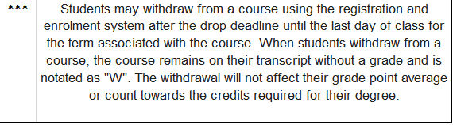

There are deadlines for adding and dropping courses, both academic and financial. Since, for the most part, the dates are different, be sure to read the information carefully so that you understand the differences between the lecture dates below and the Refund Tables.

You are strongly advised to pay close attention to the "Last date to enroll without permission of course instructor" deadlines. These deadlines represent the last date students have unrestricted access to the registration and enrolment system.

After that date, you must contact the professor/department offering the course to arrange permission.

You can drop courses using the registration and enrolment system up until the drop deadline. After that, you will receive a grade for the course.

MID-TERM EXAM: Held During the Week 6, Closed Book, 2.5 hours, covers Weeks 1 – 5 (inclusive); review lecture: Week 5. Mid-Term tests not picked-up on handout in class will be available next day at Rm. 282 Atkinson. You must produce student i.d. to retrieve your test paper. Please bring your student i.d. to the examination room.

MID-TERM EXAM RETURN: Mid-Term exams will be returned to students in the classroom within two weeks. Afterward, exam papers ONLY will be available for pick-up at Rm. 282, Atkinson as will deferred, deferred medical and accommodation examination papers.

INDIVIDUAL FEEDBACK: An opportunity for individual feedback together with a discussion of the mid-term test answer key will be available to students before the drop date.

FINAL EXAM: Held During Weeks 13-14, Closed Book, 3.0 hours, covers the entire course, all lectures; review lecture: Week 12. Please bring your student i.d. to the examination room. Your final exam marks are NOT posted on Moodle. The University releases the marks, campus wide on specific dates set aside for that purpose. Your final exam individual mark should be obtained from the support staff at Rm. 282 Atkinson. I am NOT permitted to release your final exam mark nor your final grade to you.

LECTURE BREAKS: Every lecture has a 15 - minute break normally at approximately the ½ way point, except lectures 5 and 12.

COURSE DISCUSSION / QUESTIONS: During weeks 1 – 12 either ½ hour before or ½ hour after class.

Students who miss the mid-term exam must provide a completed "Attending Physician's Statement"

http://www.yorku.ca/grads/forms/NEW/attending_physician_statement.pdf

within 5 business days of the mid-term to the School of Administrative Studies (Atkinson, Rm 282) which must include the name and phone number of a contact person who can verify the reason for absence. Failure to do so shall result in a grade of 0 for the mid-term.

- Please do NOT email your “Attending Physician’s Statement” or any supporting documentation to your course director or to the School of Administrative Studies. Only original signed copies or original supporting documents will be considered acceptable. These should be presented at Rm. 282, Atkinson Building, Keele Campus.

Students who for any reason do not attend the mid-term of the section they are enrolled in will not be permitted to write the mid-term. If a mid-term is written and the course is not dropped by the drop date, then the mid-term mark will count towards the final grade.

Weighting: **

Students who are unable to write the mid-term test on the scheduled date in the Course Outline, may, with appropriate and approved supporting documentation write a make-up mid-term examination on an alternate date set by the University LA&PS Teaching & Learning Program Administration Office. The make-up mid-term exam is automatically re-weighted from 40% to 15% of the course grade for the semester. The final exam also is automatically re-weighted from 60% to 85% of the course grade for the semester. For example, if you scored 73/100 on the make-up mid-term and 64/100 on the final exam, the net effect of the applicable weighting would be a final course grade of approximately 65/100.

Notes:

It is your responsibility as a student to ensure that you are available to sit for examinations during the entire exam period for the term corresponding to your course. We strongly recommend that you do not make any travel arrangements prior to the end of the term's examination schedule.

COURSE DESCRIPTION

This course is intended to provide students with the basic legal principles and frameworks that are necessary when one is operating within a business context. The course will introduce students to the fundamental building blocks of business law, contracts and torts (e.g., negligence). This will be followed by a discussion of the legal aspects of the different forms of business organization including: sole proprietorships; partnerships; and corporations. Other important areas of business law to be covered include: employment law; consumer law; competition law; environmental law; bailment; real estate law (including mortgages); as well as intellectual property. The course is not designed to turn students into lawyers, but to provide them with the basic knowledge and understanding of legal principles so that they are more fully aware of the legal implications of their actions in business and can more easily navigate within the Canadian legal system.

* Note that not only does Law have its own language, but its concepts and terms are more commonly expressed in formal legal English language and grammar, which students will have to understand and apply for examination purposes.

Course Learning Objectives:

The primary learning objectives of this course are as follows:

- To have a basic understanding of the key legal concepts and principles that relate to business activity, whether as an owner, professional, employee, manager, executive, or director.
- To become more aware of the legal implications that can arise while engaged in business activity in order to know when to engage the assistance of a lawyer, as well as how to be a more informed and knowledgeable legal client.
- To develop critical decision-making skills via the application of concepts and legal principles to business cases.

Student Assessments and Grading:

Assessment | Grade Weight | Date
1) Mid-Term Exam | 40%** | Week Six
2) Final Exam | 60%** | During the Final Exam Period
TOTAL | 100%

Mid-Term: The Mid-term Examination will cover materials discussed during Weeks 1 through 5 of the course. The Mid-term Examination is closed book and will take place during week 6. You are entitled to bring a clean, approved, ‘hard-copy’ (not electronic) English dictionary into the exam. You are NOT permitted to use “translation” dictionaries (i.e. to or from English and another language) or “law” dictionaries (e.g. Black’s Law Dictionary). Students should bring with them their current identification card, and their York Card or one piece of photo identification at the exam.

Final Exam: The final exam is cumulative of all of the material covered in the course, closed book, and will take place during the final exam period. You are entitled to bring a clean, approved, ‘hard-copy’ (not electronic) English dictionary into the exam. You are NOT permitted to use “translation” dictionaries (i.e. to or from English and another language) or “law” dictionaries (e.g. Black’s Law Dictionary). Students should bring with them their current identification card, and their York Card or one piece of photo identification at the exam.

Class Expectations and Participation

In general, the readings each week for the course will be quite heavy, but it is important that you take the time to do the readings and not fall behind. This will help with one’s understanding of the material presented during the lectures. It is also important to read all the assigned cases beforehand so you will be prepared to discuss them in class. Moreover, not only does Law have its own language, but its concepts and terms are more commonly expressed in formal legal English language and grammar, which students will have to understand and apply for examination purposes.

Things You Should and Should Not Do

- Attend lectures. No lecture notes will be provided outside class except those which can be found in Moodle.

- Do the weekly readings; they will help you understand the concepts

- When emailing …

  - You may not receive a response. That is because …

    - Your email has no name and / or student number
    - The information you are requesting cannot be provided, or has already been posted, or is already in Moodle / Course Outline, or will be posted or discussed in class

  - Be sure to use your own energies, creativity and initiative before engaging the professor
  - Do not request additional marks; none are available
  - Do not bother explaining to me why you could not attend a test / exam. Take it up with the University Administration at ATK 282
  - Do not write to me asking for information about a class you missed. Your responsibility is to obtain that information from a classmate
  - Do not write to me asking about the structure of a test / exam. That is well-discussed in class and it is your responsibility to be there, in attendance, to obtain that information for yourself.

COURSE OUTLINE

ADMS 2610: Elements of Law (Part i)
WEEKLY AGENDA

Subject code | instructor | Time | start date
AP/ADMS 2610 | R. Gasparini | 7:00 – 10:00 pm | September 4, 2019

 | topics covered | readings and cases
part one:  introduction contracts, torts, Security for debt, negotiable instruments and international law  Week # 1 | Sources:  Sources of Law, Constitution, Charter of Rights and Freedoms*, Judicial System, Civil Court Procedure, Administrative Tribunals, Alternative Dispute Resolution (ADR) Legal Profession | Chapter 1  Chapter 2  Chapter 3 (pp. 50 – 51 / 53 – 57)  Assigned Cases for this lecture:  Case 3, p. 25, Case 1, p. 49 and Case 2, p. 58.  *See: Extra Reading
contracts  part 1  WEEK # 2 | Contracts (1):  Introduction to Contracts  The Elements of a Valid Contract and Intention to Create a Legal Relationship  Offer and Acceptance  The Requirement of Consideration  Quantum Meruit  The Legal Capacity to Contract and the Requirement of Legality  The Requirement of Form and Writing | Chapter 7  Chapter 8  Chapter 9  Chapter 10  Assigned Cases for this lecture:  Case 8, p. 136, Case 4, p. 149, Case 10, p. 173-4 and Case 9, p. 191
SEPT 20  contracts  part 2  WEEK # 3 | Contracts (2):  The Failure to Create an Enforceable Contract; Mistake, Misrepresentation and Undue Influence  The Extent of Contractual Rights; Privity; Assignment  The Performance of Contractual Obligations; Discharge;  Breach of Contract and Remedies for Breach; Fundamental Breach; Remedies; Damages; Mitigation; Specific Performance; Enforcement of Judgments | Chapter 11  Chapter 12  Chapter 13  Chapter 14  Assigned Cases for this lecture:  Case 1, p. 207, Case 3, p. 223, Case 9, p. 241 and Case 1, p. 259
torts and professional liability  WEEK # 4 | Torts:  Intentional Torts, Business and Related Torts & Crimes, Unintentional Torts, Vicarious Liability, Negligence, the Concept of Foreseeability, Manufacturer’s Liability, Tort Defenses, Remedies, Professional Standards and Professional Obligations, Professional-Client Relationships | Chapter 4  Chapter 5  Chapter 6  Assigned Cases for this lecture:  Mini-Cases 1, p. 77, 2 and 3, pp. 96-7 and 1, p. 112
part two:  special legal rights & relationships  security for debt, negotiable instruments and international law  WEEK # 5 | Security for Debt: Forms, Statutory Protection for Creditor Security, Priorities  Negotiable Instruments: Bills of Exchange, Cheques, Promissory Notes, Defences, Consumer Protection and Negotiable Instruments  International Business Law: Importing and Exporting Goods to and from Canada, International Trade Regulation, International Trading Relationships and Contracts of Sale, International Trade Dispute Arbitration* | Chapter 29  Chapter 28  Chapter 33  No cases assigned this week.  *See Extra Reading  Note: The second half of this lecture will be a review in preparation for the Mid-Term Examination next week.
test  wk 6 | MID TERM EXAMINATION  (2.5 hours), Closed Book  Location for Test MAY be different than the regular lecture room. Please check with Course Director. | This test will cover all the material discussed in Weeks 1 – 5 (above) including textbook, power points, lecture notes and any supplementary material assigned for study.
part three:  business organizations  forms of business  WEEK # 7 | Business Organizations Other Than Corporations:  Sole Proprietorship, Partnership, Partnership Liability for Acts of Employees, Rights and Duties of Partners to One Another, Dissolution of Partnership, Limited Partnership, Limited Liability Partnership | Chapter 16  Assigned Cases for this lecture:  Case 1, p. 300, Case 2, p. 300 and Case 7, p. 302
WEEK # 8 AND AT  HOME OR MOBILE  THIS LECTURE IS IN TWO PARTS:  (1) LIVE IN CLASS  (2) RECORDED  forms of business  (continued)  DISTRIBUTORSHIPS  LICENSES  FRANCHISES  JOINT VENTURES  COOPERATIVES  THE CORPORATION | Business Organizations:  Part One: Live – In Class (Power Point)  Distributorships, Licenses, Franchises, Joint Ventures and Cooperatives  IN CLASS  ---------------------------------------------------------  AT HOME OR MOBILE  Part Two: Recorded – Moodle Topic 8  The Corporation: Nature of a Corporation, Obtaining a Corporate Name, Methods of Incorporation, The Indoor Management Rule, Articles of Incorporation, The Incorporation Process, Shareholders’ Agreements, Corporate Securities, Division of Corporate Powers, The Taxation of Corporations, Duties and Responsibilities of Directors, Director’s Liability, Defense of Due Diligence, Sarbanes Oxley Act, Shareholders’ Rights, Purchase and Sale of a Corporation | Chapter 17 + Lecture Notes  Assigned Cases for this lecture: Cases 3, p. 328, 8, p. 330 and 10, p. 331.  This lecture is in TWO parts. The first is live, in class. The second is recorded and divided into 3 – I-hour sessions (with videos and audio accompanying Power Points) which you will find in Moodle, Topic 8. It is accessible anywhere including your iPhone or Android.  Lecture notes for the live portion are available in Moodle, Topic 8.  (see page 7 for Chapter Number and Assigned Cases)  Tests returned to classroom today at the latest; Rm. 282 Atkinson afterward.
part three:  miscellaneous business law  WEEK # 9  agency, bailment and employment law | Employment Law: Contract of Employment, Dismissal and Wrongful Dismissal, Employer Misrepresentation, Employer Liability to Third parties, Employer Liability for Employee’s Injuries  Agency: Role of an Agent, Agency by Express Agreement, Duties of Parties, Agency by Conduct or Estoppel, Agency by Operation of Law, Ratification of contracts by the Principal, Agency Relationship  Bailment: Nature and Types of Bailment, Bailor-Bailee | Chapter 9 (pp.166-168 only)  Chapter 19  Chapter 15  Chapter 20  Assigned Cases for this lecture:  Case 9, p. 283, Case 9, p. 407, and Case 2, p. 381
government regulation of business:  sale of goods  consumer protection  restrictive trade practices  environmental law  WEEK # 10 | Sale of Goods: Codification of the Law, Nature of a Contract of Sale, Contractual Duties, Remedies, Electronic Sale of Goods  Consumer Protection Legislation: Consumer Safety, Consumer Information, Consumer – Product Quality and Performance Protection, Consumer Protection Related to Business Practices, Credit-Granting Consumer Protection, Credit Reporting Consumer Protection  Restrictive Trade Practices: Mergers, Conspiracies and Combinations in Restraint of Trade, Offences Relating to the Distribution and Sale of Products, Civil Actions under the Competition Act  Environmental Law: Common Law, Environmental Legislation, “The Polluter Pays” Principle, Responsibility for Contamination | Chapter 21  Chapter 27  Chapter 32  Chapter 34  Assigned Cases for this lecture:  Case 6, p. 430, Case 5, p. 552, Case 2, p. 648 and Case 3, p. 682
REAL PROPERTY LAW  MORTGAGES  LEASEHOLD INTERESTS  WEEK # 11 | Real Property Law: Easements, Restrictive Covenants, Title to Land, Registration of Property Interests  Mortgages: Priorities, Rights and Duties of the Parties, Special Clauses, Discharge of Mortgage, Assignment, Sale of Mortgaged Property, Default: Foreclosure and Sale, Business Applications of Mortgage Security  Leasehold Interests: Creation of a Tenancy, Rights and Duties of the Landlord and the Tenant, Rights of the Landlord for Breach of the Lease, Rights of the Tenant for Breach of the Lease | Chapter 22  Chapter 23  Chapter 24  Assigned Cases for this lecture:  Mini-Cases 2, 3 and 4, p. 451
INTELLECTUAL PROPERTY LAW  WEEK # 12  COURSE ENDS | Intellectual Property Law: Power Point  Patents, Trademarks, the Trademarks Act, Franchises, Copyright, the Copyright Act  Break  Final Exam Review | Chapter 26  No Cases Assigned This Week  Note: The second half of this lecture will be a review in preparation for the Final Examination Date TBA.
EXAM PERIOD  DEC 5 - 20  TBA | FINAL EXAMINATION  Closed Book – 3.0 hours  The specific exam date for this class to be announced by Course Director. Please check Course Website regularly! | The final examination covers the entire course (all chapters)  PLEASE SEE MARKING RUBRICS FOR FINAL EXAM BELOW

RELEVANT UNIVERSITY REGULATIONS

Deferred Exams: Deferred standing may be granted to students who are unable to write their final examination at the scheduled time or to submit their outstanding course work on the last day of classes. Details can be found at http://myacademicrecord.students.yorku.ca/deferred-standing
Any request for deferred standing on medical grounds must include an Attending Physician's Statement form; a “Doctor’s Note” will not be accepted.
DSA Form: http://www.registrar.yorku.ca/pdf/deferred_standing_agreement.pdf
Attending Physician's Statement form: http://registrar.yorku.ca/pdf/attending-physicians-statement.pdf
To apply for deferred standing, students must register at
http://apps.eso.yorku.ca/apps/adms/deferredexams.nsf
Followed by handing in a completed DSA form and supporting documentation directly to the main office of the School of Administrative Studies (282 Atkinson) and add your ticket number to the DSA form. The DSA and supporting documentation must be submitted no later than five (5) business days from the date of the exam. These requests will be considered on their merit and decisions will be made available by logging into the above-mentioned link. No individualized communication will be sent by the School to the students (no letter or e-mails).
Students with approved DSA will be able to write their deferred examination during the School's deferred examination period. No further extensions of deferred exams shall be granted. The format and covered content of the deferred examination may be different from that of the originally scheduled examination. The deferred exam may be closed book, cumulative and comprehensive and may include all subjects/topics of the textbook whether they have been covered in class or not. Any request for deferred standing on medical grounds must include an Attending Physician's Statement form; a “Doctor’s Note” will not be accepted.
Academic Honesty: The Faculty of Liberal Arts and Professional Studies considers breaches of the Senate Policy on Academic Honesty to be serious matters. The Senate Policy on Academic Honesty is an affirmation and clarification for members of the University of the general obligation to maintain the highest standards of academic honesty. As a clear sense of academic honesty and responsibility is fundamental to good scholarship, the policy recognizes the general responsibility of all faculty members to foster acceptable standards of academic conduct and of the student to be mindful of and abide by such standards. Suspected breaches of academic honesty will be investigated and charges shall be laid if reasonable and probable grounds exist.
Students should review the York Academic Honesty policy for themselves at:
http://www.yorku.ca/secretariat/policies/document.php?document=69
Students might also wish to review the interactive on-line Tutorial for students on academic integrity, at:
https://spark.library.yorku.ca/academic-integrity-what-is-academic-integrity/
Grading Scheme and Feedback Policy: The grading scheme (i.e. kinds and weights of assignments, essays, exams, etc.) shall be announced, and be available in writing, within the first two weeks of class, and, under normal circumstances, graded feedback worth at least 15% of the final grade for Fall, Winter or Summer Term, and 30% for ‘full year’ courses offered in the Fall/Winter Term be received by students in all courses prior to the final withdrawal date from a course without receiving a grade, with the following exceptions:
Note: Under unusual and/or unforeseeable circumstances which disrupt the academic norm, instructors are expected to provide grading schemes and academic feedback in the spirit of these regulations, as soon as possible. For more information on the Grading Scheme and Feedback Policy, please visit: http://www.yorku.ca/univsec/policies/document.php?document=86
In-Class Tests and Exams - the 20% Rule: For all Undergraduate courses, except those which regularly meet on Friday evening or on a weekend, tests or exams worth more than 20% will not be held in the two weeks prior to the beginning of the official examination period. For further information on the 20% Rule, please visit: http://secretariat-policies.info.yorku.ca/policies/limits-on-the-worth-of-examinations-in-the-final-classes-of-a-term-policy/
Reappraisals: Students may, with sufficient academic grounds, request that a final grade in a course be reappraised (which may mean the review of specific pieces of tangible work). Non-academic grounds are not relevant for grade reappraisals; in such cases, students are advised to petition to their home Faculty. Students are normally expected to first contact the course director to discuss the grade received and to request that their tangible work be reviewed. Tangible work may include written, graphic, digitized, modeled, video recording or audio recording formats, but not oral work. Students need to be aware that a request for a grade reappraisal may result in the original grade being raised, lowered or confirmed. For reappraisal procedures and information, please visit the Office of the Registrar site at: http://myacademicrecord.students.yorku.ca/grade-reappraisal-policy
Accommodation Procedures: LA&PS students who have experienced a misfortune or who are too ill to attend the final examination in an ADMS course should not attempt to do so; they must pursue deferred standing. Other students should contact their home Faculty for information. For further information, please visit: http://ds.info.yorku.ca/academic-support-accomodations/
Religious Accommodation: York University is committed to respecting the religious beliefs and practices of all members of the community, and making accommodations for observances of special significance to adherents. For more information on religious accommodation, please visit:
https://w2prod.sis.yorku.ca/Apps/WebObjects/cdm.woa/wa/regobs
Academic Accommodation for Students with Disabilities (Senate Policy)
The nature and extent of accommodations shall be consistent with and supportive of the integrity of the curriculum and of the academic standards of programs or courses. Provided that students have given sufficient notice about their accommodation needs, instructors shall take reasonable steps to accommodate these needs in a manner consistent with the guidelines established hereunder. For more information, please visit the Counselling and Disability Services website at http://www.yorku.ca/dshub/
York’s disabilities offices and the Registrar’s Office work in partnership to support alternate exam and test accommodation services for students with disabilities at the Keele campus. For more information on alternate exams and tests please visit http://www.yorku.ca/altexams/
Please alert the Course Director as soon as possible should you require special accommodations.
Alternate Exams:

Alternate Exam and test requests must be submitted at least three (3) weeks in advance of the scheduled test dates. Late requests to book tests or exams will not be accepted by the Alternate Exams online request system. It is your responsibility to check your e-mail regularly for notifications regarding changes or updates concerning Alternate Exam and Test Scheduling services.
To reschedule an exam or test for students currently registered with Counselling & Disability Services, follow these steps.

- Contact your course instructor for permission to reschedule the exam or test. Please note that permission to reschedule is at the discretion of the course instructor and is not guaranteed. Scheduling is dependent on space availability. If you have been corresponding with your course instructor by e-mail and have confirmation of their approval to reschedule, you may upload, attach or send a copy of the e-mail as an electronic signature from the course instructor.

- If permission is granted by your instructor, complete and submit a signed Alternate Exam and Test Rescheduling Request Form at least five (5) business days in advance of the rescheduled exam/test date.

- Review the Policies and Procedures for writing your rescheduled exam/test.

  - Please use Microsoft Internet Explorer, Google Chrome, Apple Safari or Adobe Acrobat to fill out the online form in your browser or save it and open with Adobe Acrobat.

- Note: If you are requesting to reschedule an exam/test as a religious accommodation, ensure that you check the box located on the top of the form. Information regarding religious observance policy and accommodation can be found in the York Courses Web site.

- If you are submitting a request to write an exam or test on a date that falls after the Faculty deadlines for submission of deferred final grades, you must petition for deferred standing through your home Faculty. In this circumstance, submit an Alternate Exam and Test Rescheduling Request Form only if your petition is granted.

FINAL EXAM MARKING RUBRICS FOR
PARTS II AND IV FOLLOW

Final Exam, Part Two, Reflective Answer Rubric Part Value = 30
Total Marks Available for Each of Three Questions = 10
Criteria | Superior (8-10 points) | Sufficient (5-8 points) | Minimal (1-4 points) | Unacceptable (0 points)
Depth of Reflection  (25% of TTL Points) | Response demonstrates an in-depth reflection on, and personalization of, the theories, concepts, and/or strategies presented in the course materials to date. Viewpoints and interpretations are insightful and well supported. Clear, detailed examples are provided, as applicable. | Response demonstrates a general reflection on, and personalization of, the theories, concepts, and/or strategies presented in the course materials to date. Viewpoints and interpretations are supported. Appropriate examples are provided, as applicable. | Response demonstrates a minimal reflection on, and personalization of, the theories, concepts, and/or strategies presented in the course materials to date. Viewpoints and interpretations are unsupported or supported with flawed arguments. Examples, when applicable, are not provided or are irrelevant | Response demonstrates a lack of reflection on, or personalization of, the theories, concepts, and/or strategies presented in the course materials to date. Viewpoints and interpretations are missing, inappropriate, and/or unsupported. Examples, when applicable, are not provided.
Required Components  (25% of TTL Points) | Response includes all components and meets or exceeds all requirements indicated in the instructions. Each question is addressed thoroughly. | Response includes all components and meets all requirements indicated in the instructions. Each part of question is addressed. | Response is missing some components and/or does not fully meet the requirements indicated in the instructions. Some parts of the question are not addressed. | Response excludes essential components and/or does not address the requirements indicated in the instructions. Many parts of the question are addressed minimally, inadequately, and/or not at all.
Structure  (25% of TTL Points) | Writing is clear, concise, and well organized with excellent sentence/paragraph construction. Thoughts are expressed in a coherent and logical manner. There are no more than three spelling, grammar, or syntax errors per page of writing. | Writing is mostly clear, concise, and well organized with good sentence/paragraph construction. Thoughts are expressed in a coherent and logical manner. There are no more than five spelling, grammar, or syntax errors per page of writing. | Writing is unclear and/or disorganized. Thoughts are not expressed in a logical manner. There are more than five spelling, grammar, or syntax errors per page of writing. | Writing is unclear and disorganized. Thoughts ramble and make little sense. There are numerous spelling, grammar, or syntax errors throughout the response.
Evidence and Practice  (25% of TTL Points) | Response shows strong evidence of synthesis of ideas presented and insights gained throughout the entire course. The implications of these insights for the respondent's overall teaching practice are thoroughly detailed, as applicable. | Response shows evidence of synthesis of ideas presented and insights gained throughout the entire course. The implications of these insights for the respondent's overall teaching practice are presented, as applicable. | Response shows little evidence of synthesis of ideas presented and insights gained throughout the entire course. Few implications of these insights for the respondent's overall teaching practice are presented, as applicable. | Response shows no evidence of synthesis of ideas presented and insights gained throughout the entire course. No implications for the respondent's overall teaching practice are presented, as applicable.

Final Exam, Part Four, Problem Question
Part Value = 30

The rubric in this document demonstrates the evaluation of varying levels of performance expressed in a range of ways and evaluated accordingly.

Grading structure of the Part 4 (30 mark) question

0 - 14 | 15 - 19 | 20 - 24 | 24 - 30
Unacceptable | Minimally acceptable | Acceptable | Exceeds expectations

Each of the categories above is defined below:

Unacceptable | Minimally acceptable | Acceptable | Exceeds expectations
The answer has several errors in both conceptual level and communication clarity. Multiple mechanical errors or complete failure to answer the question | The answer contains one or two basic facts that are correct, but may also have incorrect statements as well. No connections or comparisons provided. | The answer contains most (75%) of the points that needed to be included. The writing is clear, if uninspired. | The answer not only contains the main points but goes beyond them to provide a critique of their veracity. The writing is clear and measured.

The point value or level in addition to or in place of the scale shown above, like this:

Component | Possible point value
All main ideas are included and expressed | 10 points total
Ideas have been analyzed with care | 10 points total
Ideas have been connected in a logical manner | 5 points
Writing is clear and coherent, precise and accurate | 5 points

Possible Point Value Breakdown

CATEGORY | Most points Zero points
Clarity | Grammar, spelling, and style make it easy for the reader to follow. Uses words correctly and avoids jargon unless it is the most precise word. | Occasional (2 or 3 per page) grammar, spelling or style problems. Tendency to use vague words or excessive jargon. | Problems in grammar, spelling or style that interfere with the author's statements. (Multiple problems in each paragraph). | Significant problems in grammar, spelling or style that make it challenging to follow the author's statements.
Accuracy | All statements are accurate relative to the resource being examined and/or to the material in the textbook. | All statements are accurate relative to the resource being examined and/or to the material in the textbook. | No more than one minor inaccuracy per page. | More than one inaccuracy per page.
Precision/  Logic | Statements are at the best level of information that answers the question--not too vague but not "lost in the details" and missing the big picture. Statements are mutually supporting and follow from one another. Any contradictions are explained. | Most statements are at the best level of information that answers the question--not too vague but not "lost in the details" and missing the big picture. Statements are usually mutually supporting and follow from one another. Any contradictions are explained. | Statements are sometimes on target and sometimes off center. Segments of the paper hang together but other parts are unclear or contradictory with no good resolution. | Fails to provide a level of information that answers the question--either too vague or filled with trivial details. Statements are internally contradictory without explanation.
Relevance/  Significance | Achieves the learning objectives of the task. Topic is significant to both the course and in larger senses. | Achieves the learning objectives of the task. Topic is obviously central to the course. | Achieves learning objectives minimally. Topic choice is only vaguely related to the assignment. | Fails to achieve the learning objectives of the task. The topic is trivial or irrelevant to question.
Depth/Breadth | Response displays a full understanding of the complexity of the issue addressed and multiple points of view. Recognizes varied interpretations and implications. | Of the following 2 tasks, does one well and the other partially or does both partially  a) Recognizing varied points of view  b) Exploring the topic in depth from one point of view. | Of the following 2 tasks, does one well and the other not at all or does both minimally  a) Recognizing varied points of view  b) Exploring the topic in depth from one point of view. | Response is both narrower than appropriate and superficial. Fails to recognize varied interpretations and implications of topic.

