AP/DEMS3705 A - Emergency Management: Field Experience (Fall 2021)
Pre-requisites: AK/ADMS3700 3.00 and AK/ADMS3701 3.00
Open to: Open only to those students enrolled in the Emergency Management Certificate or BDEM.

Course Director: Ali Asgary
Disaster & Emergency Management
School of Administrative Studies
York University, Toronto, Ontario
Email: asgary@yorku.ca

Course Description
This course provides students with the opportunity of working in various organizations to observe professional Emergency Managers, and to apply theoretical knowledge in the field. Students will have taken two of the core courses as pre-requisites (ADMS 2700 and ADMS 3701)which will provide the foundational knowledge about the four pillars of mitigation, preparedness, response and recovery, as well as the assessment of risk. Students will relate this knowledge to projects or situations in the field and will critically reflect on the integration of both theory and experience in in-vivo situations. Pedagogically, the course design is based on the principles of experiential education.
The field experience fosters the deepening of learning through reflection on the theory-experience dynamic. Additionally, students acquire experience that may benefit them in terms of future academic work or in terms of career preparation.
Students are responsible for finding their own placements, which must be suitable to the university as a positive learning environment for the student.
Students are expected to work 12 hours per week for 11 weeks (132 hours) with the host institution.

Course Evaluation
Items | Marks | Due Date
Questionnaire #1 | 5% | Second week of placement
Questionnaire #2: | 5% | Middle of the placement
Work Term Report: | 40% | April 16
Organization evaluation: | 50% | April 16

3. Work Term Report Contents
Please submit a field experience report by no later than December 16.
The report should be a professional report covering the following items:
- Introduction (about yourself before going to the field experience course- courses taken, 1 page )
- About the Field Experience Organization (Maximum 1 page)
- About the Field Experience Office and Supervisor (Maximum 1 page)
- About your time schedule in the organization (Maximum 1 page)
- About the projects that you were involved in (Minimum 6 pages)
- Relationship between what you leaned in the program with the project you were involved in the field experience (2 pages) 5. Lessons learned (2 pages maximum)
- Issues and challenges (1 page maximum)
- Conclusion (1 page maximum)
- Appendices (as needed- sample of works if shareable, photos if shareable, etc.)

4. Organization evaluation
Students upon completion of their work download and provide an evaluation form to their host organization’s supervisor. He/she complete the form and send it to the course director by email at asgary@yorku.ca. It is up to the supervisor to share or not to share the evaluation form with the student.
Please give the attached evaluation form to your supervisor at the end of your work. He/She need to fill it in and either email it directly to me or give it to you to download it in Moodle.
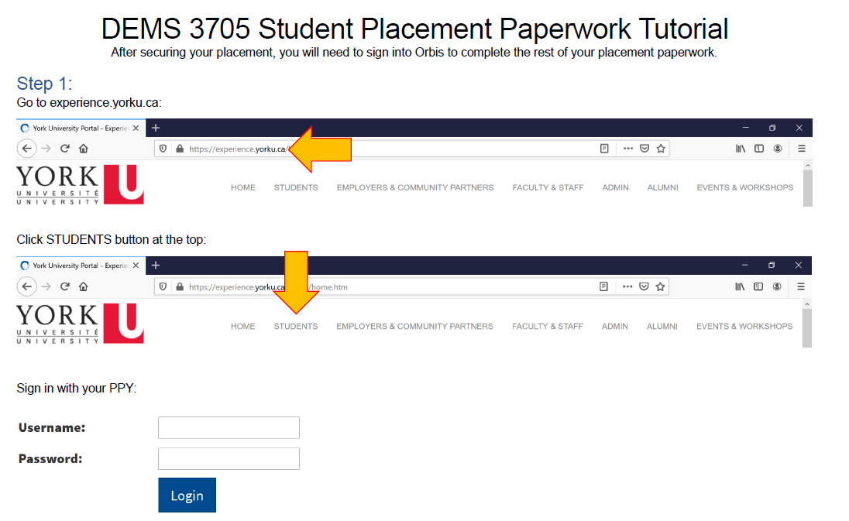

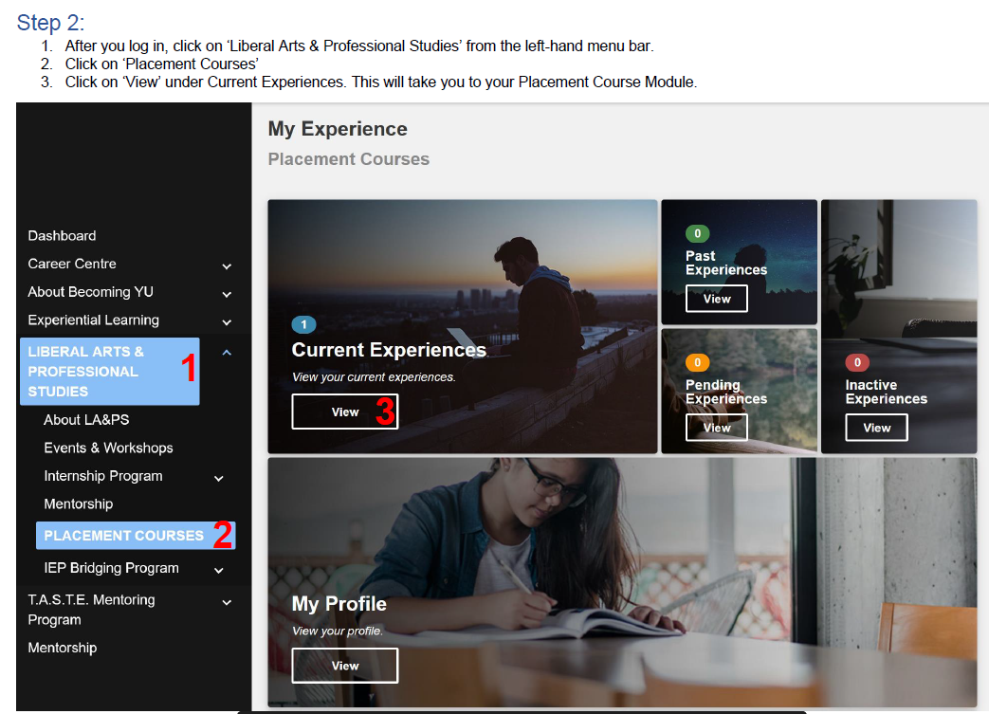
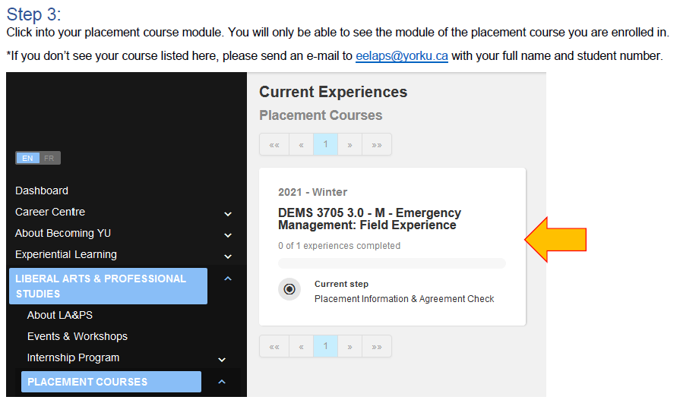

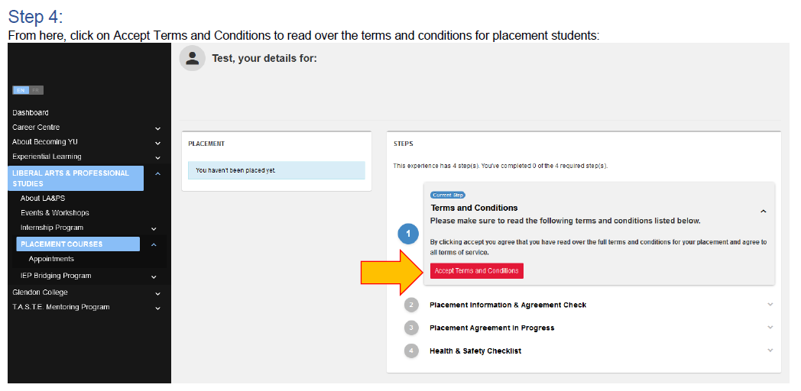
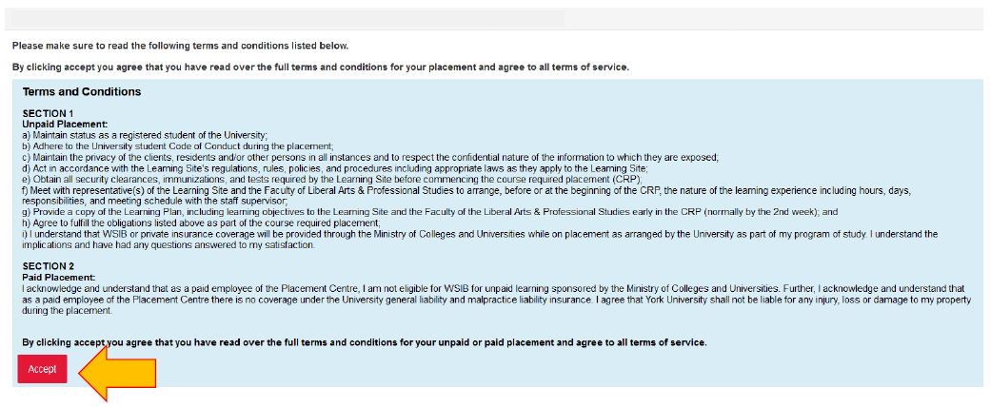
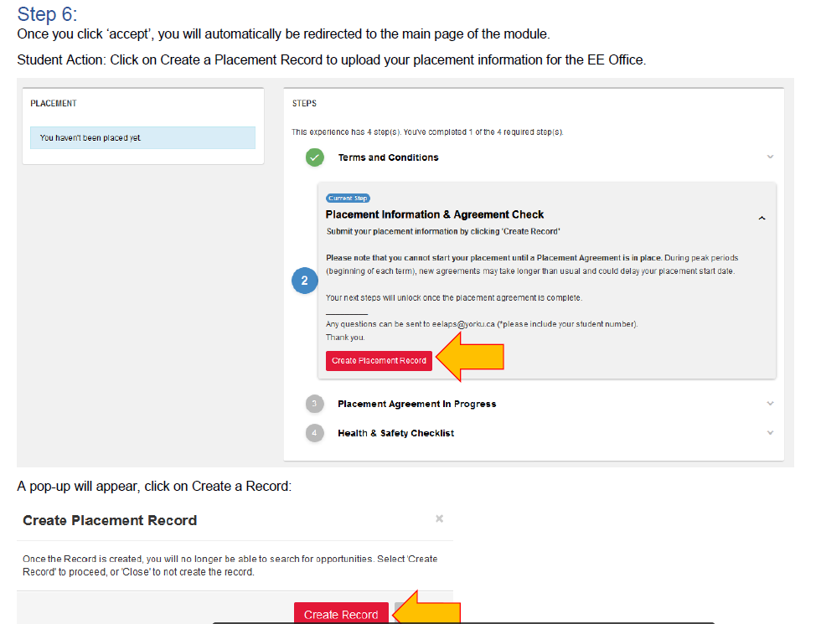

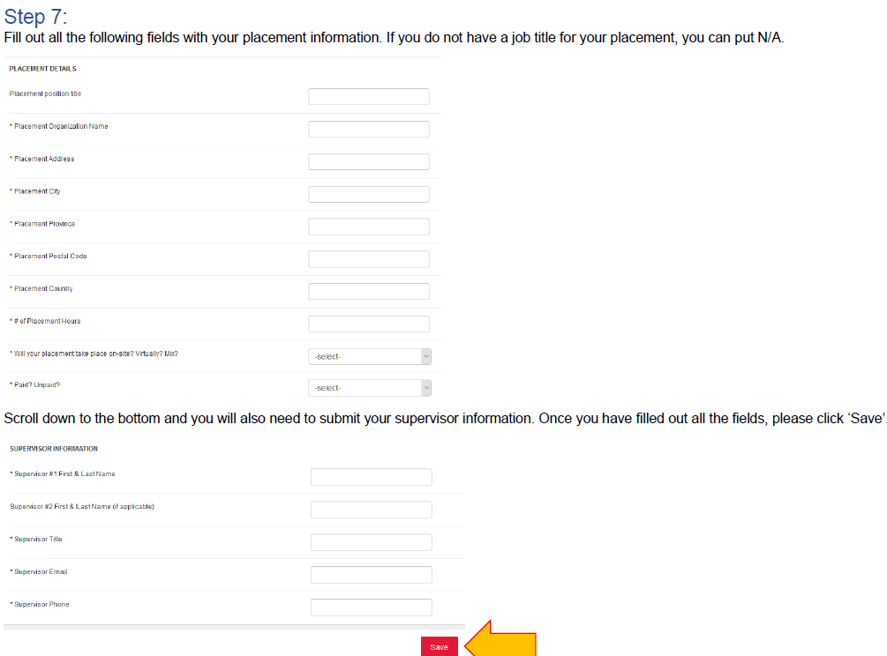
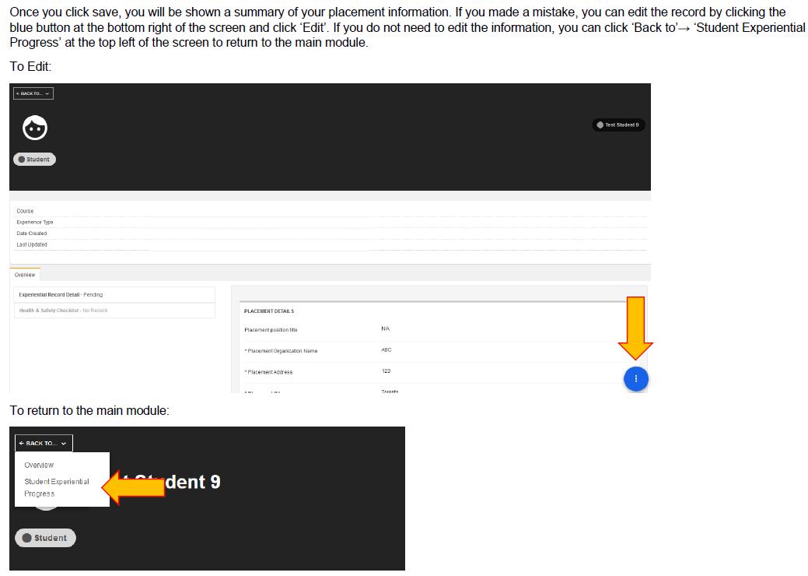

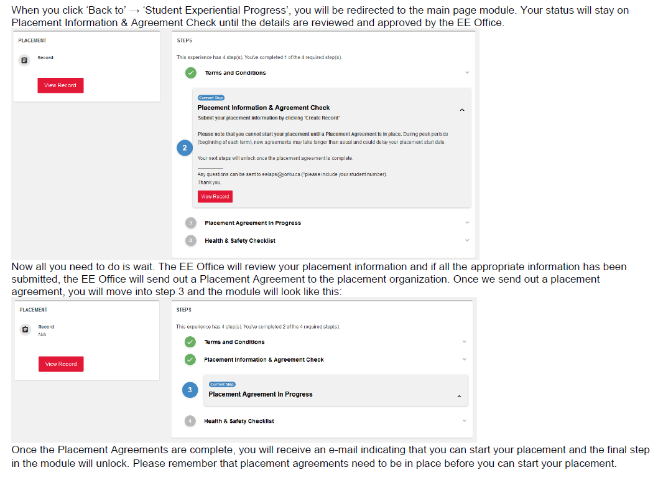
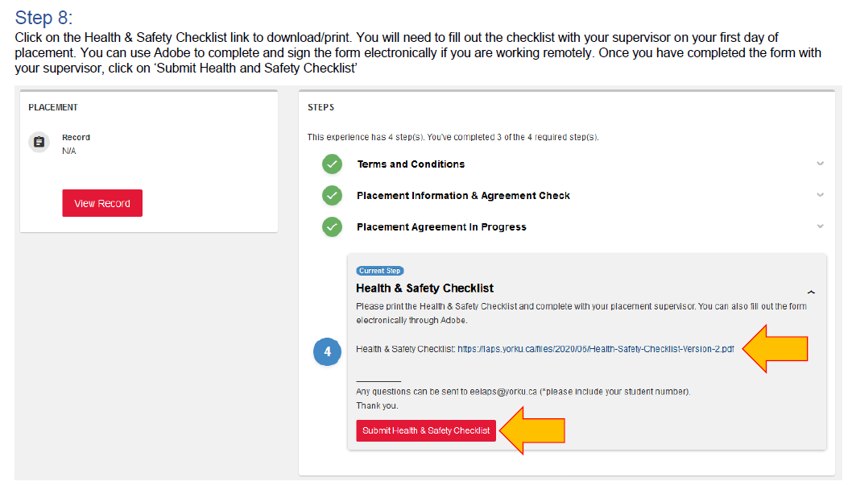

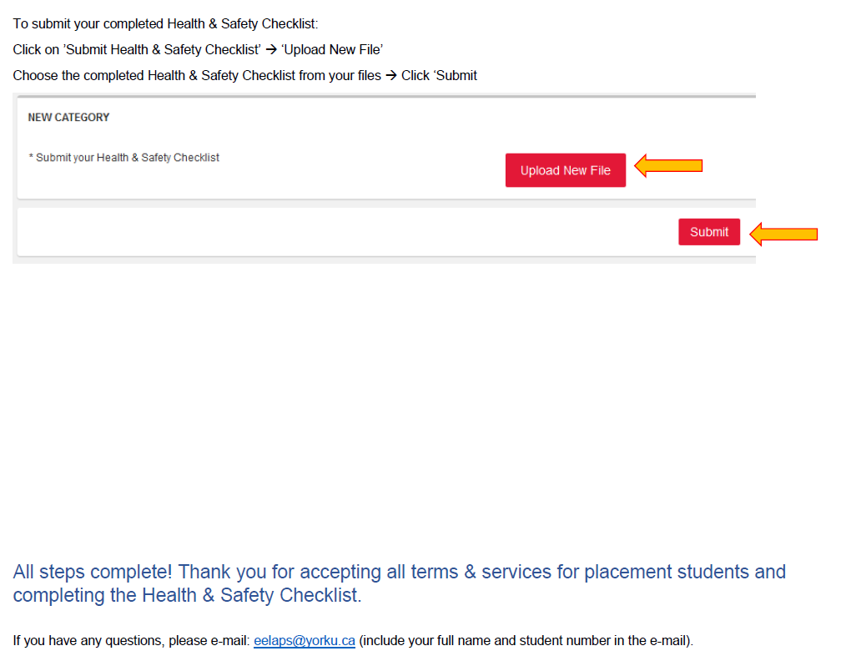
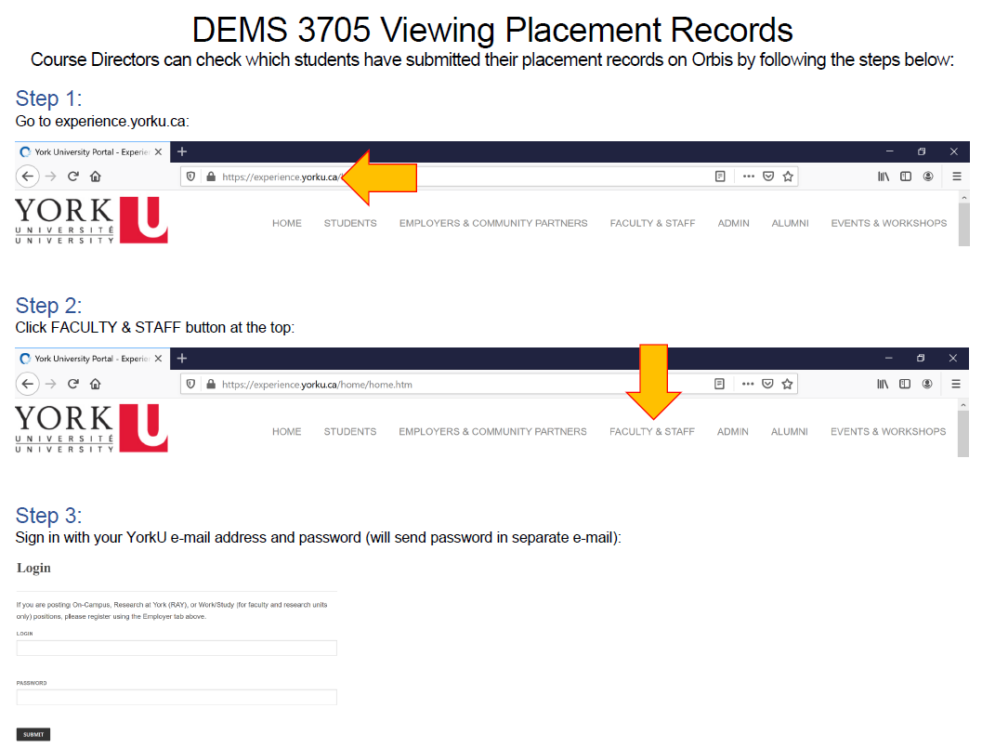

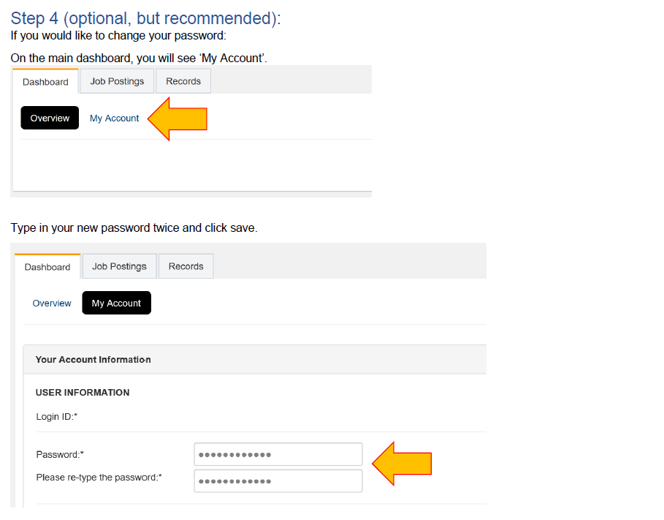
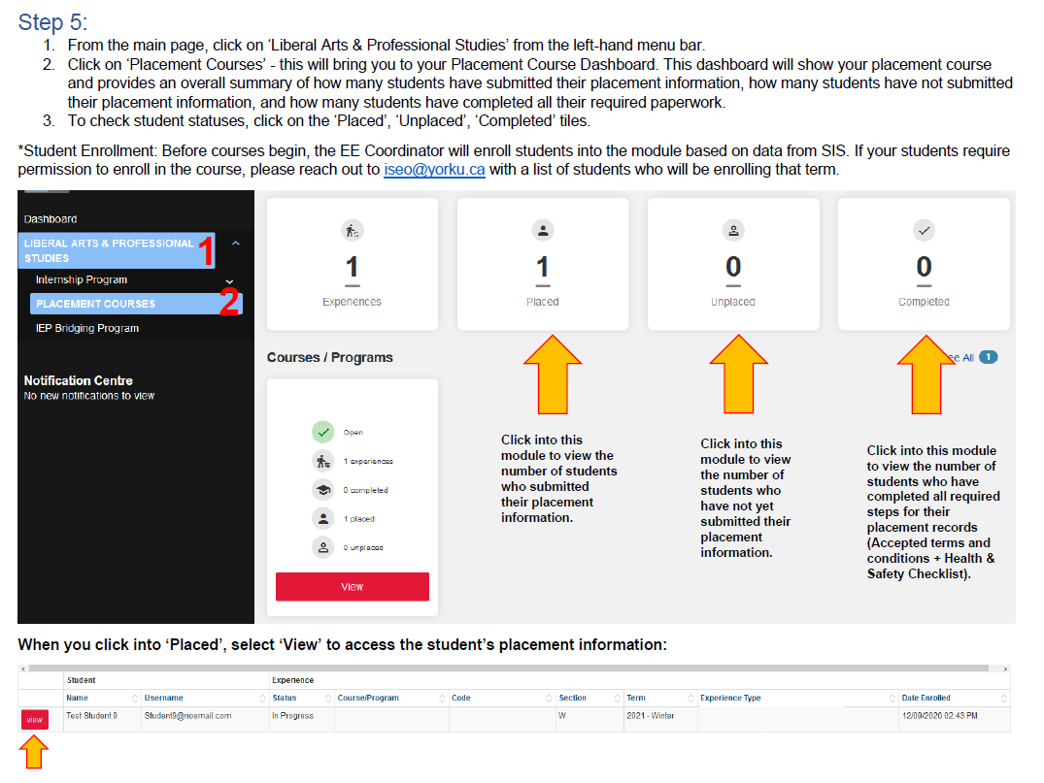
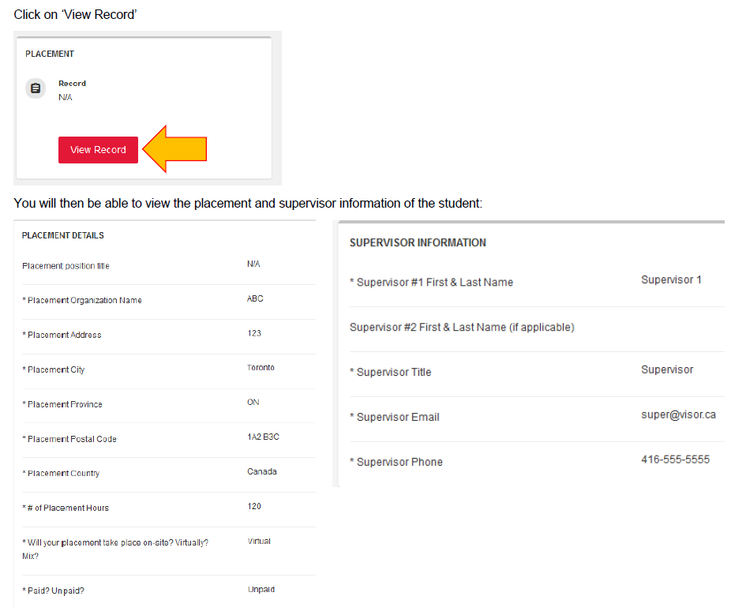
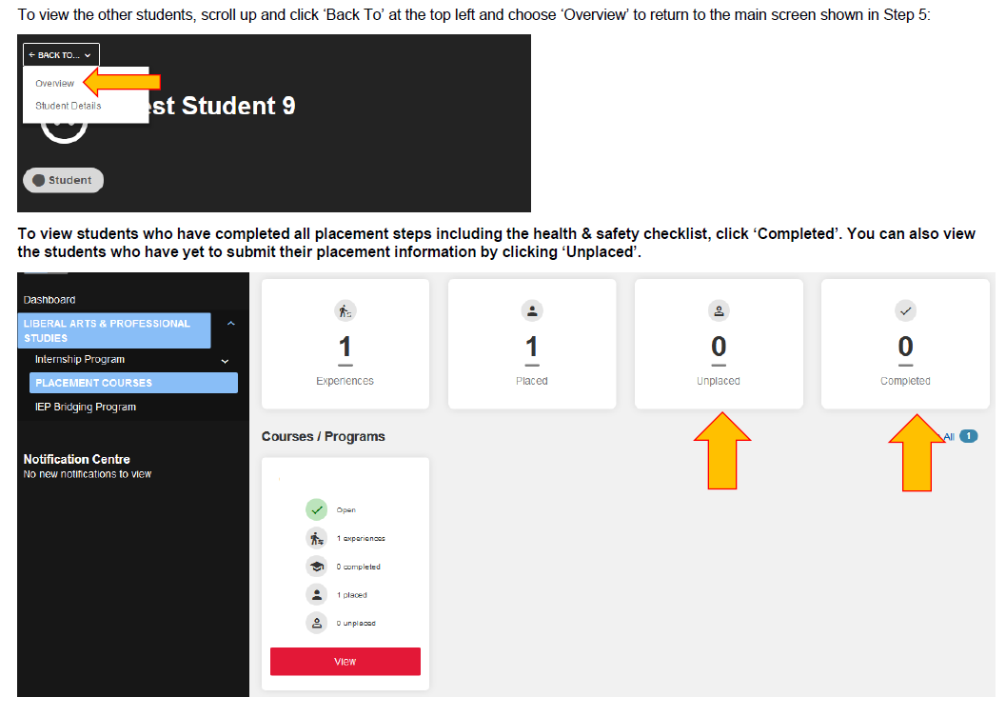

RELEVANT UNIVERSITY/LA&PS/SCHOOL REGULATIONS
Applicable to all ADMS and DEMS courses
Deferred Final Exams: Deferred standing may be granted to students who are unable to write their final examination at the scheduled time or to submit their outstanding course work on the last day of classes. Details can be found at http://myacademicrecord.students.yorku.ca/deferred-standing
Any request for deferred standing on medical grounds must include an Attending Physician's Statement form; a “Doctor’s Note” will not be accepted.
DSA Form: http://www.registrar.yorku.ca/pdf/deferred_standing_agreement.pdf
Attending Physician's Statement form: http://registrar.yorku.ca/pdf/attending-physicians-statement.pdf
In order to apply for deferred standing, students must register at:
http://sas-app.laps.yorku.ca
Followed by handing in a completed original Deferred Standing Agreement (DSA) form and supporting documentation directly to the main office of the School of Administrative Studies (282 Atkinson) and add your ticket number to the DSA form. During this time of remote learning, you will be required to submit the forms via email to apsas@yorku.ca. The DSA and supporting documentation must be submitted no later than five (5) business days from the date of the exam. These requests will be considered on their merit and decisions will be made available by logging into the above-mentioned link. No individualized communication will be sent by the School to the students (no letter or e-mails).
Students with approved DSA will be able to write their deferred examination during the School's deferred examination period. Deferred exams might take place during the regular exams period or in subsequent weeks depending on the course; precise dates are known when the Office of the Registrar publishes the final exam schedule of the term. No further extensions of deferred exams shall be granted. The format and covered content of the deferred examination may be different from that of the originally scheduled examination. The deferred exam may be closed book, cumulative and comprehensive and may include all subjects/topics of the textbook whether they have been covered in class or not.
Academic Honesty: The Faculty of Liberal Arts and Professional Studies considers breaches of the Senate Policy on Academic Honesty to be serious matters. The Senate Policy on Academic Honesty is an affirmation and clarification for members of the University of the general obligation to maintain the highest standards of academic honesty. As a clear sense of academic honesty and responsibility is fundamental to good scholarship, the policy recognizes the general responsibility of all faculty members to foster acceptable standards of academic conduct and of the student to be mindful of and abide by such standards. Suspected breaches of academic honesty will be investigated and charges shall be laid if reasonable and probable grounds exist.
Students should review the York Academic Honesty policy for themselves at:
http://www.yorku.ca/secretariat/policies/document.php?document=69
Students might also wish to review the interactive on-line Tutorial for students on academic integrity, at:https://spark.library.yorku.ca/academic-integrity-what-is-academic-integrity/
Grading Scheme and Feedback Policy: The grading scheme (i.e. kinds and weights of assignments, essays, exams, etc.) shall be announced, and be available in writing, within the first two weeks of class, and, under normal circumstances, graded feedback worth at least 15% of the final grade for Fall, Winter or Summer Term, and 30% for ‘full year’ courses offered in the Fall/Winter Term be received by students in all courses prior to the final withdrawal date from a course without receiving a grade, with the following exceptions:
Note: Under unusual and/or unforeseeable circumstances which disrupt the academic norm, instructors are expected to provide grading schemes and academic feedback in the spirit of these regulations, as soon as possible. For more information on the Grading Scheme and Feedback Policy, please visit: http://www.yorku.ca/univsec/policies/document.php?document=86
In-Class Tests and Exams - the 20% Rule: For all Undergraduate courses, except those which regularly meet on Friday evening or on a weekend, tests or exams worth more than 20% will not be held in the two weeks prior to the beginning of the official examination period. For further information on the 20% Rule, please visit: http://secretariat-policies.info.yorku.ca/policies/limits-on-the-worth-of-examinations-in-the-final-classes-of-a-term-policy/
Reappraisals: Students may, with sufficient academic grounds, request that a final grade in a course be reappraised (which may mean the review of specific pieces of tangible work). Non-academic grounds are not relevant for grade reappraisals; in such cases, students are advised to petition to their home Faculty. Students are normally expected to first contact the course director to discuss the grade received and to request that their tangible work be reviewed. Tangible work may include written, graphic, digitized, modeled, video recording or audio recording formats, but not oral work. Students need to be aware that a request for a grade reappraisal may result in the original grade being raised, lowered or confirmed. For reappraisal procedures and information, please visit the Office of the Registrar site at: http://myacademicrecord.students.yorku.ca/grade-reappraisal-policy
Accommodation Procedures: LA&PS students who have experienced a misfortune or who are too ill to attend the final examination in an ADMS course should not attempt to do so; they must pursue deferred standing. Other students should contact their home Faculty for information. For further information, please visit: http://ds.info.yorku.ca/academic-support-accomodations/
Religious Accommodation: York University is committed to respecting the religious beliefs and practices of all members of the community and making accommodations for observances of special significance to adherents. For more information on religious accommodation, please visit:
https://w2prod.sis.yorku.ca/Apps/WebObjects/cdm.woa/wa/regobs
Academic Accommodation for Students with Disabilities (Senate Policy)
The nature and extent of accommodations shall be consistent with and supportive of the integrity of the curriculum and of the academic standards of programs or courses. Provided that students have given sufficient notice about their accommodation needs, instructors shall take reasonable steps to accommodate these needs in a manner consistent with the guidelines established hereunder. For more information, please visit the Student Accessibility Services (formerly known as Counselling and Disability Services) website at https://accessibility.students.yorku.ca
York’s disabilities offices and the Registrar’s Office work in partnership to support alternate exam and test accommodation services for students with disabilities at the Keele campus. For more information on alternate exams and tests please visit http://www.yorku.ca/altexams/
Please alert the Course Director as soon as possible should you require special accommodations.

