FW(Y)/ F/ W 2025-26 + SU26
AP/FR 0120 A 6.0 (Y) | Basic French (CEFR A1)
Course Director: | Name: Roxaneh Naghshi  Office: Ross N733  Ext.: 20724  E-mail: rnaghshi@yorku.ca  Office hours: by appointment
Time: | T-R 10:30-12:30
Delivery Format: | ⃝ LECTURE
Expanded Course Description: | AP/FR 0120 is designed for students who have not studied French, or who do not have sufficient French to be admitted to an Advanced Beginner class.  Students are encouraged to develop their oral and written skills systematically through the use of dialogues, role-playing, and conversations in pairs, small groups or in class with the instructor.  Pronunciation is practiced through repetition exercises in class, online or at home via the audio files found on eClass.  Oral comprehension is practiced through dictation and/or listening exercises that will sensitize students to the sounds, rhythm and delivery of standard French, auditory discrimination exercises and global comprehension of a message.  Basic vocabulary and grammatical structures of the language are introduced without delay, allowing students to express themselves at an early stage.  Students will be given various written exercises and will practice writing simple sentences, paragraphs and very short compositions. Grammatical and lexical errors will be corrected.  Reading comprehension will be developed through the reading of short passages on a culture theme and the reading of dialogues.  The more the course progresses, the more French will be used (teaching and activities).
Required Course text/readings: | - Textbook: This course will be requiring the purchase of the following Books which is available at the York Bookstore.  These are available both in print or digital version.  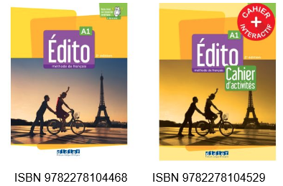
Prerequisites: | By placement test and permission of the department
Weighting of Course | Oral Work 25%  Written Work 30%  Listening 25%  Activities 15%  Participation & Engagement in the course 5%
Organization of the course | In person lecture, Year term: LECT (Y)
Course Learning Objectives | AP/FR 0120 aims at enabling students to read and write simple French, understand and follow everyday conversations and take part in oral exchanges in French within the limits of the grammar structures and vocabulary covered in the course. Upon successful completion of the course, students will have acquired listening, speaking, reading and writing skills necessary to take French courses at the intermediate level.  More specifically, at the end of the course the student should be able to:  - demonstrate awareness of basic cultural facts;  - know the basic sound system of French;  - know the basic lexical categories and morphological and syntactic patterns of the French language (e.g. gender, verb conjugation patterns, word order in simple sentences); recognizes differences with English;  - use basic vocabulary and correct verb forms to introduce oneself, describe daily routines, indicate likes and dislikes, ask questions relating to people and one’s surroundings;  - comprehend basic information presented orally or in written form;  - create and edit short paragraphs (50-100 words) in basic correct French to describe a person or place, to provide directions;  - participate in a basic conversation in French relating to daily life situations and routines, demonstrating an ability to understand others and to make oneself understood in a rudimentary way;  - ask questions to clarify what has been misunderstood;  - use correctly the present tense of regular verbs and of common irregular verbs; begins to use the past tenses of regular and common irregular verbs;  - read information presented and responds in writing, e.g. by answering a short survey about oneself, interests and routines, by writing a short answer.
Additional Information/Notes | NA

